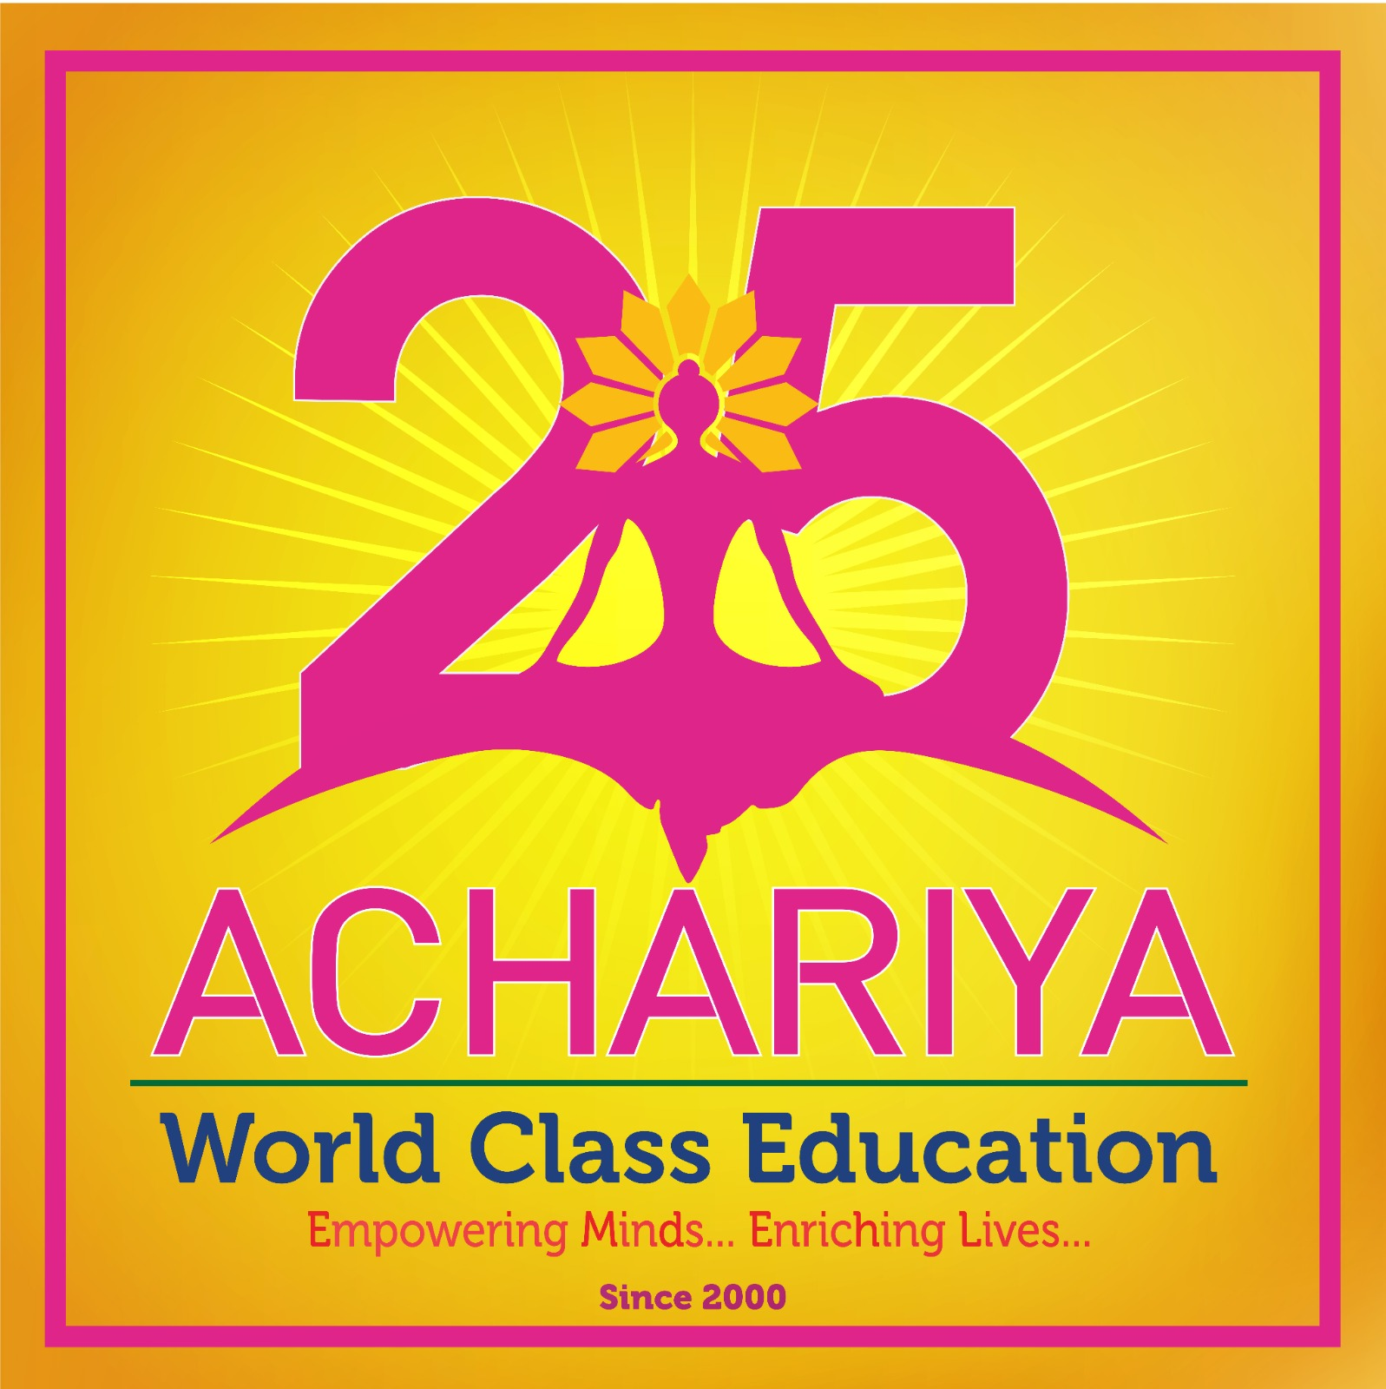
ACHARIYA ARTS AND SCIENCE COLLEGE
(Affiliated to Pondicherry University)
Recognized by UGC under section 2(f) of UGC act 1956
Achariyapuram, Villianur, Puducherry - 605110. Ph: 0413 – 2660731

ACTIVITY REPORT

Department | DEPARTMENT OF MULTIMEDIA (Visual Communication) | Event Date and Time | 28.11.2025  10 am to 4pm
Title of the Program/Event | NEXT-GEN MEDIA: THE POWER OF ARTIFICIAL INTELLIGENCE WORKSHOP | No of Participants (Count) | 20
Category of the event (Seminar / Guest Lecture / Symposium / FDP/ Orientation Programme / Refresher course/ Short Term Course/ Research Methodology/ Intellectual Property Rights(IPR)/ Entrepreneurship/ Skill development/ Placement Training/ Soft Skill/ Life Skill/ Awareness in Trends in Technology / Exhibition / College Common Function / Sports / Competition / Extension Activity / Conference/ workshop/Training/Others (Mention)) | WORKSHOP | Name of the Chief Guest , Designation, Organization details etc | Mr. Nappolian Academic Head  Mr. Anto Pradeep Faculty & Project Lead (UI / UX Designer)
Event Organizer | Mr. Vinu. A. | No of days of the event | One day
Details of the Audience (Ex: Class/ Program/ External participants) | I Bsc  II Bsc  III Bsc | Associated External Agency (if any) | Aakhaash institute of media studies, Pondicherry
Objective of the event(4 Points) | - Provide an overview of AI technologies and their applications in the media sector.  - Demonstrate practical AI tools for content creation, editing, analytics, and workflow automation.  - Discuss the ethical considerations, opportunities, and risks associated with AI-driven media.  - Encourage participants to envision and prototype AI-powered solutions for real-world media challenges. | Venue – Offline | Aakhaash institute of media studies, Pondicherry

One Page Report
The Visual Communication student’s attended one day work shop entitled by Next-Gen Media: The Power of Artificial Intelligence at Aakhaash institute of media studies Pondicherry.
The Next-Gen Media: The Power of Artificial Intelligence workshop explored how rapidly evolving AI technologies are reshaping the media landscape. Participants included media professionals, content creators, educators, technologists, and business leaders. The aim was to develop a deeper understanding of AI’s capabilities, limitations, and opportunities across content creation, distribution, personalization, and media ethics.Automated text generation for news, marketing, and scriptwriting. Session Hosted by : Mr. Nappolian - Academic Head Mr. Anto Pradeep – Faculty & Project Lead (UI / UX Designer)
AI-assisted video editing, visual effe cts, image generation, and voice synthesis, Real-time translation and multilingual content production, Tools enabling creators to produce high-quality content with fewer resources the topics are covered by the workshop
The Next-Gen Media: The Power of Artificial Intelligence workshop successfully empowered participants with essential knowledge and hands-on experience to navigate the future of media. As AI continues to reshape the digital landscape, such training is crucial for preparing the next generation of media innovators and ensuring responsible, impactful use of emerging technologies.

Outcomes of the Workshop
- Emerging AI technologies and their role in transforming journalism, entertainment, advertising, and social media.
- Automated editing, captioning, and content-optimization platforms.
- Workflow automation to reduce production time and costs.
- Share experiences, challenges, and best practices with peers from diverse sectors.
- A clearer understanding of how to balance creativity, technology, and responsible AI use

Invitation  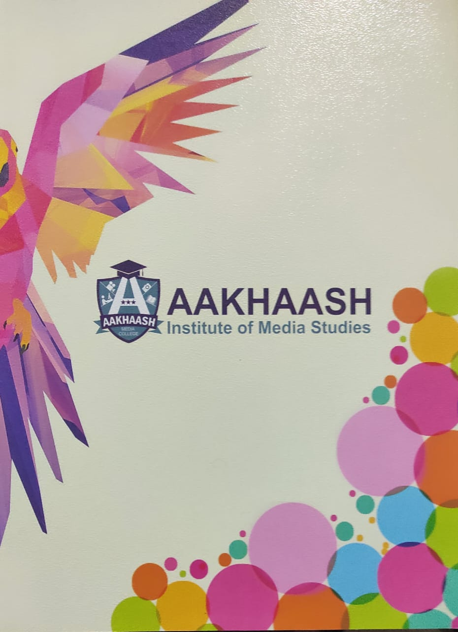 | 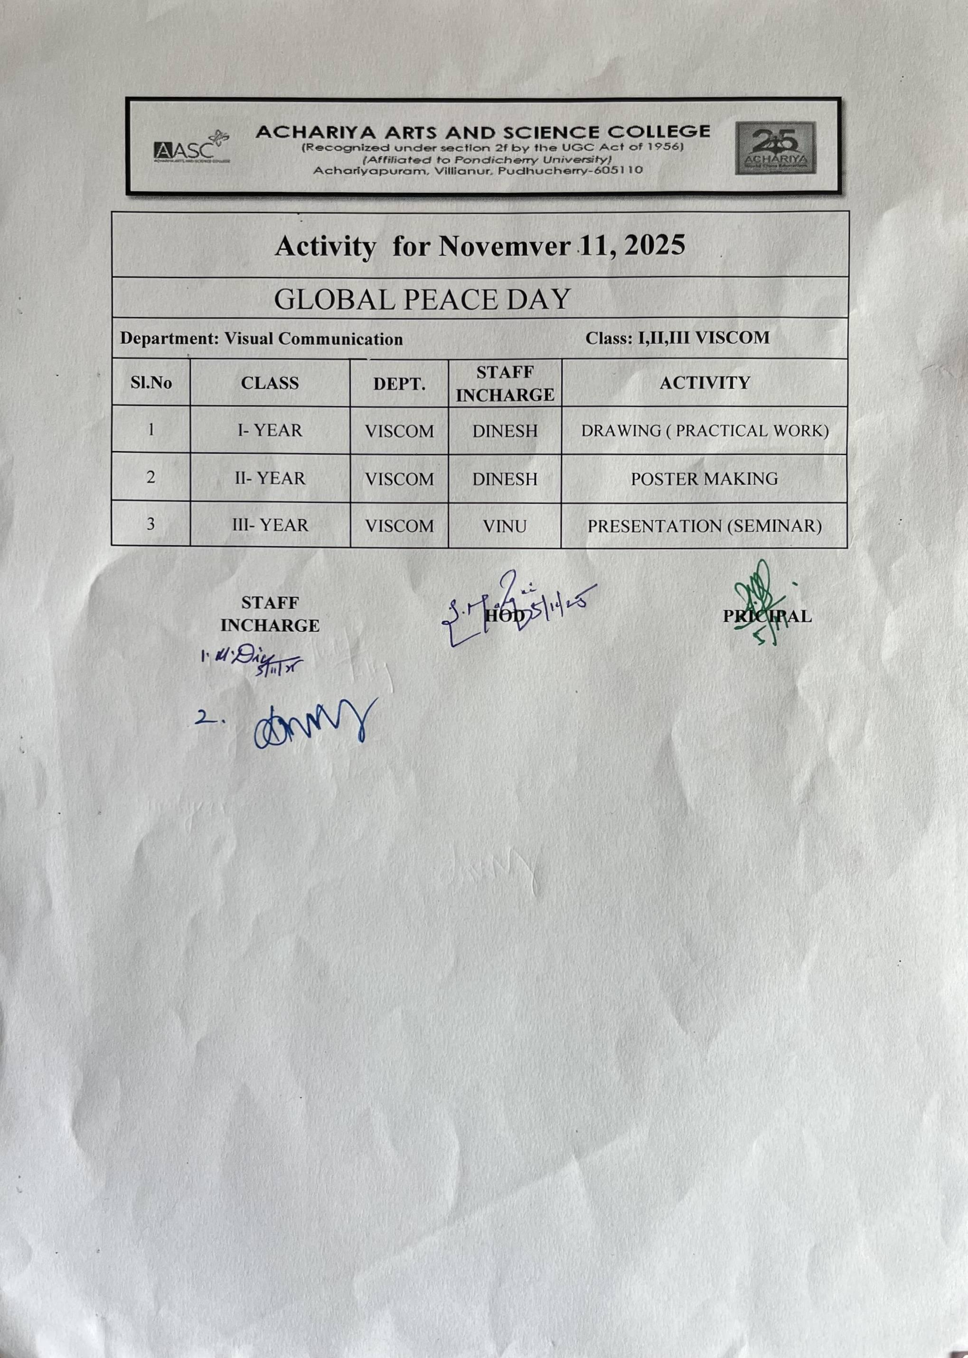  Mail communication
GEO tag photos 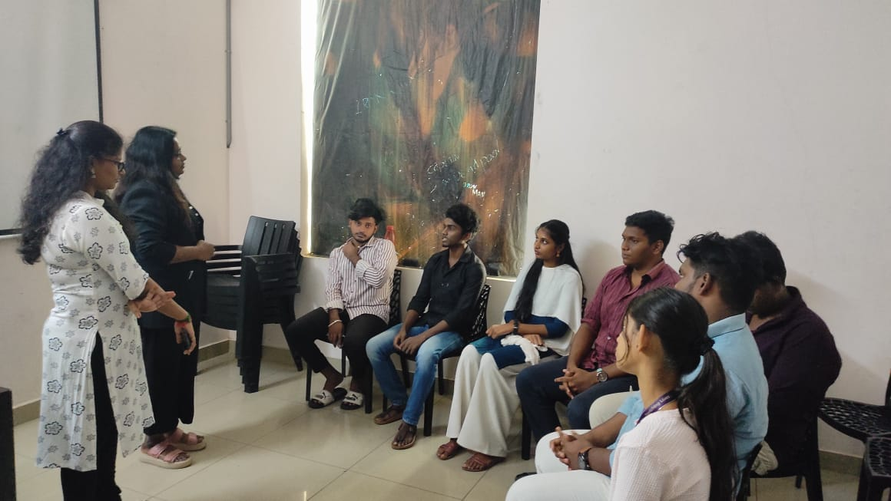  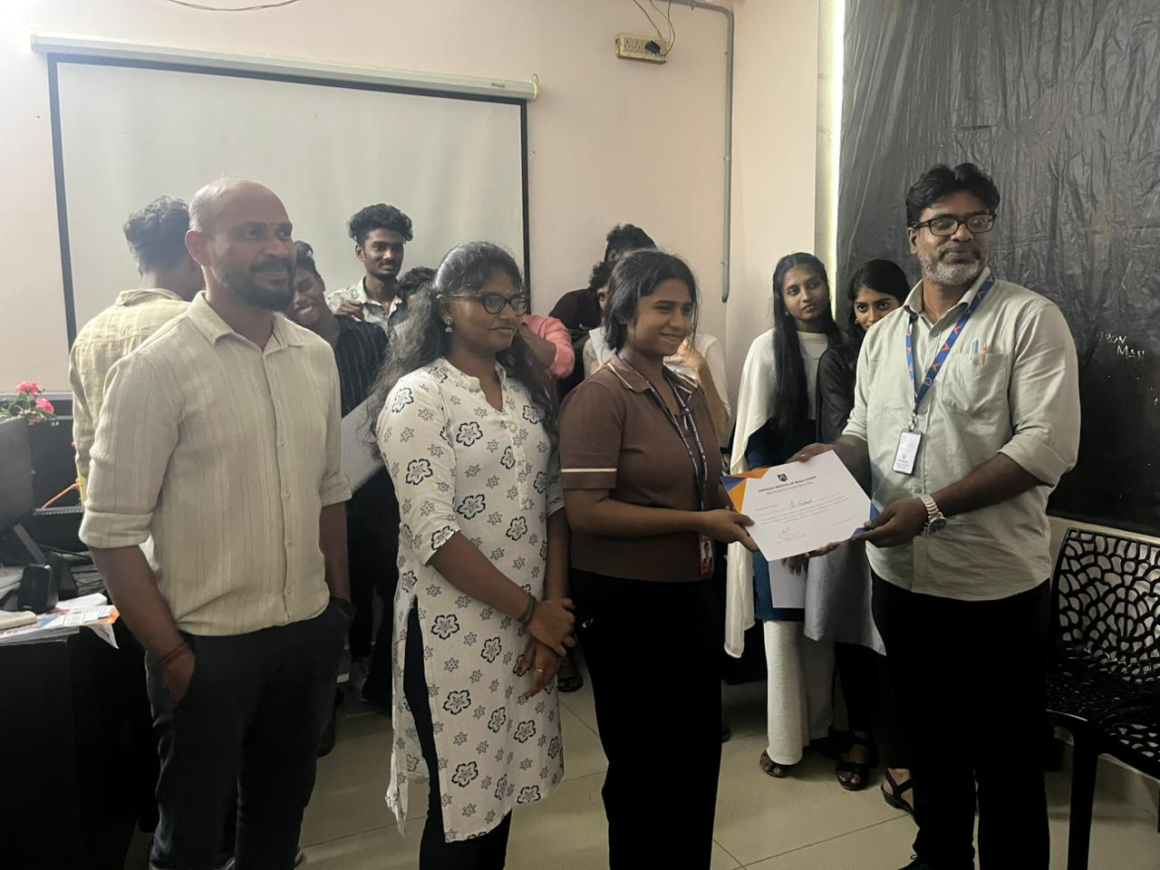  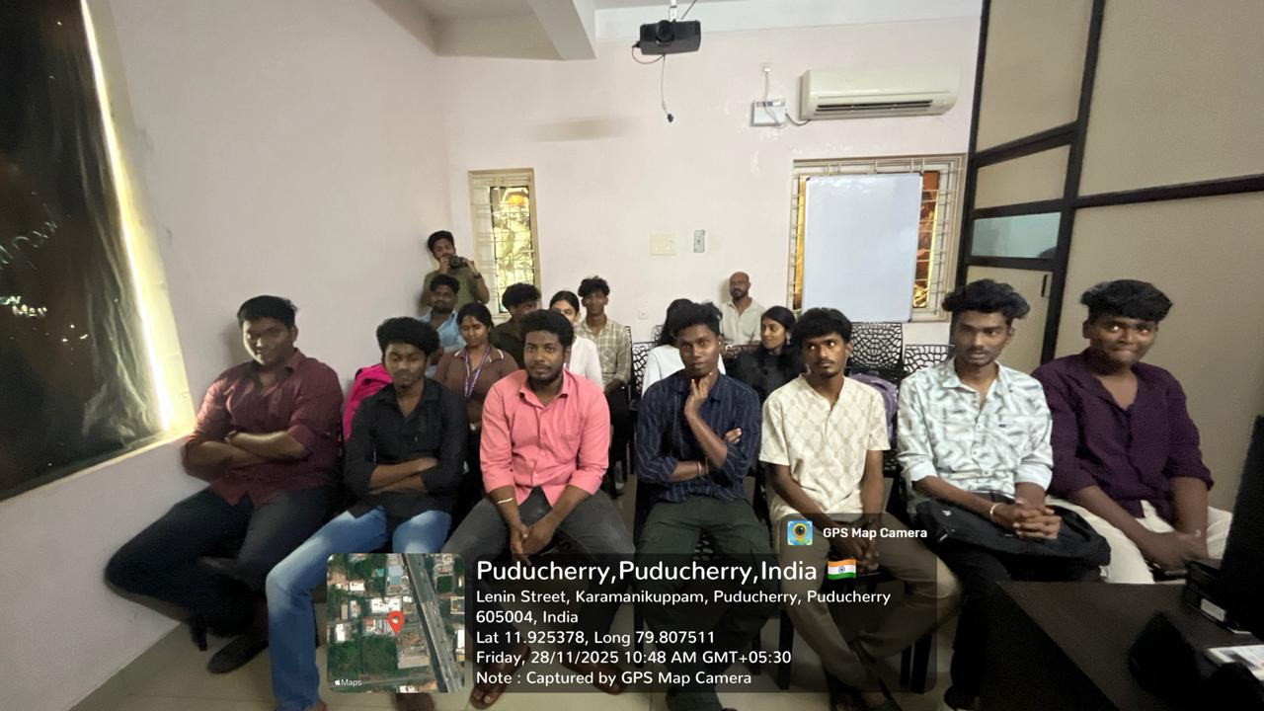  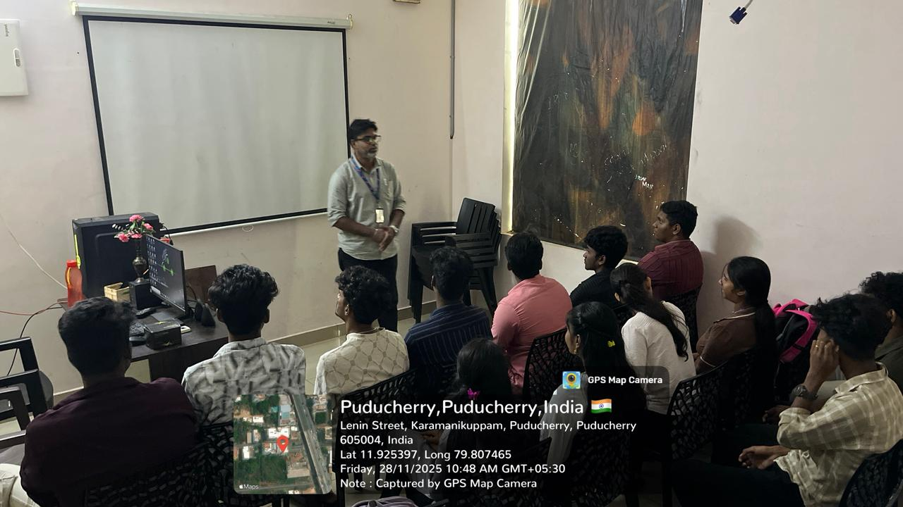 | Screenshot of Social Media Post

PARTICIPANTS LIST

Department | Department of Multimedia (Visual Communication) | Event Date and Time | 28.11.2025  10am to 4pm
Title of the Program/Event | Next-Gen Media: The Power of Artificial Intelligence / Workshop | No of Participants (Count) | 22
S NO | REG NO | NAME | CLASS/ PROGRAMME
 | 25AASC176 | ABINESH V | I BSc
 | 25AASC294 | ISHWARYA SHARMA P
 | 25AASC074 | PAVANA S
 | 25AASC293 | SUNIL KUMAR S
 | 25AASC132 | SURYA PRASATH S
 | 25AASC2330 | MOHAMED YASAR R
 | 24VC0101 | ABISH G | II BSc
 | 24VC0102 | AJAY B
 | 24VC0103 | BALAMURALI K
 | 24VC0104 | KALPESH P
 | 24VC0106 | PRAVEEN KUMAR M
 | 24VC0107 | ROHIT MURAT A
 | 24VC0108 | SAARATHI G
 | 24VC0109 | SRI VENKATESH E
 | 24VC0110 | UDHAYARASU R
 | 23VC0101 | ANCHANASHREE B | III BSc
 | 23VC0106 | KARTHIK RAJA A
 | 23VC0107 | KHALID ALI K
 | 23VC0108 | MONISHAN A
 | 23VC0111 | SASI KUMAR R
 | 23VC0112 | SUBASRI M
 | 23VC0113 | V SAM VICTOR

ORGANIZER HOD

